1.Select Ceil(8.29) As Ceil_Value From Dual;

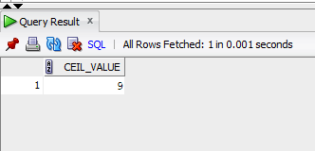

2.Select Ceil(-3.9) As Ceil_Negative From Dual;

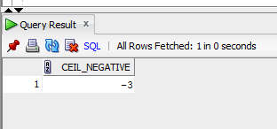

3.Select Ceil(17/3) As Ceil_Division From Dual;

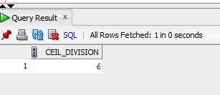

4.Select Floor(9.76) As Floor_Value From Dual;

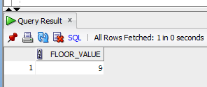

5.Select Floor(-5.3) As Floor_Negative From Dual;

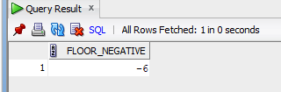

6.Select Floor(15/4) As Floor_Division From Dual;

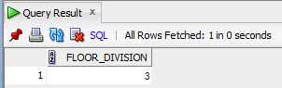

7.Select Sqrt(625) As Square_Root From Dual;

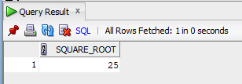

8.Select Sqrt(2) As Square_Root_2 From Dual;

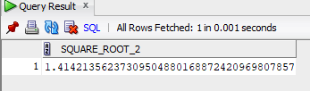

9.Select Abs(8.29) As Absolute_Value From Dual;

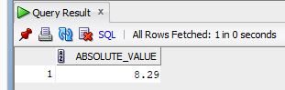

10.Select Abs(-3.14) As Absolute_Negative From Dual;

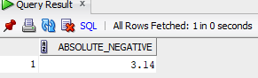

11.Select Abs(-42) As Absolute_Column_Value From Dual;

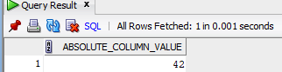

12.Select Sysdate As Now From Dual;

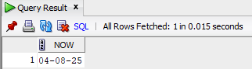

13.Select To_Char(Sysdate, 'DD-MON-YYYY HH24:MI:SS') As Date_Time_Format From Dual;

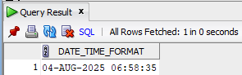

14.Select Systimestamp As System_Timestamp From Dual;

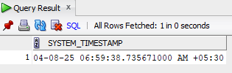

15.Select Least('Apple', 'Banana', 'Cherry') As Least_String From Dual;

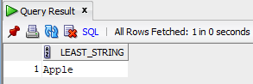

16.Select Greatest('Apple', 'Banana', 'Cherry') As Greatest_String From Dual;

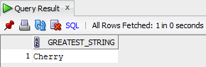

17.Select Ltrim(' Trim me') As Leading_Spaces_Removed From Dual;

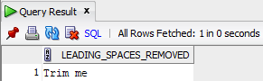

18.Select Rtrim('I love India ') As Trailing_Spaces_Removed From Dual;

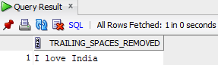

19.SELECT RPAD('Anjaly', 15, 'X') AS Right_Padded_Name FROM DUAL;

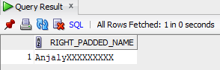

20.Select Rpad(To_Char(123), 6, '0') As Right_Padded_Number From Dual;

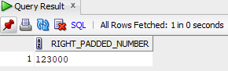

21.Select Reverse_String('uoyevol I') As Reversed From Dual;

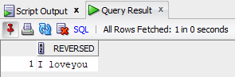

22.SELECT CASE WHEN 'racecar' = reverse ('racecar') THEN 'Palindrome'

ELSE 'Not Palindrome' END AS Result From Dual;

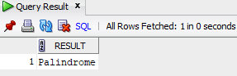

23.Select Length('Oracle Database') As String_Length From Dual; 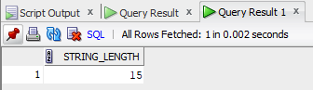

24. Select 'Oracle'||' '||'SQL'||' '||'is'||' '||'powerful'||' '||'and'||' '||'flexible' From Dual;

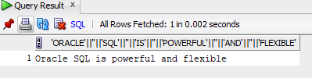

25.Select Concat('Anjaly','S') As Full_Name From Dual;

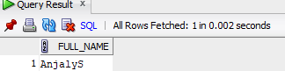

26. Select Substr('India is my country',Instr('India is my country','is'),2) As Substring_Is From Dual; 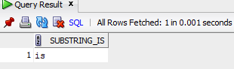

27.Select Substr('Anjaly', 3, 3) As Middle_Three_Chars From Dual; 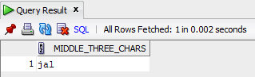

28.Select Substr('Substring', 1, 3) As First_Three_Chars From Dual;

